pUML

phunctional UML editor

<< User Manual >>

|  |
| --- |
| **pUML User Manual** |

Contents

What is pUML? 3

Installation Instructions 4

Introduction to the pUML main window. 5

Create a New Diagram 6

Editing Your Diagram 9

Help / FAQ 10

# What is pUML?

pUML is a fantastic UML diagram drawing software developed by a team of eight geniuses, currently students at the University of Idaho. This software was developed for a school project, and is by no means considered to be complete, useful, or phunctional at time of this user manual publication.

# Installation Instructions

Carefully follow the installation instructions to ensure pUML is successfully installed on your computer.

1. *Run* the installer from the download.
2. Select your preferred program file path (we recommend the default) from the Installation Wizard.
3. Click “Install”.
4. When installation has completed, click “Close”.

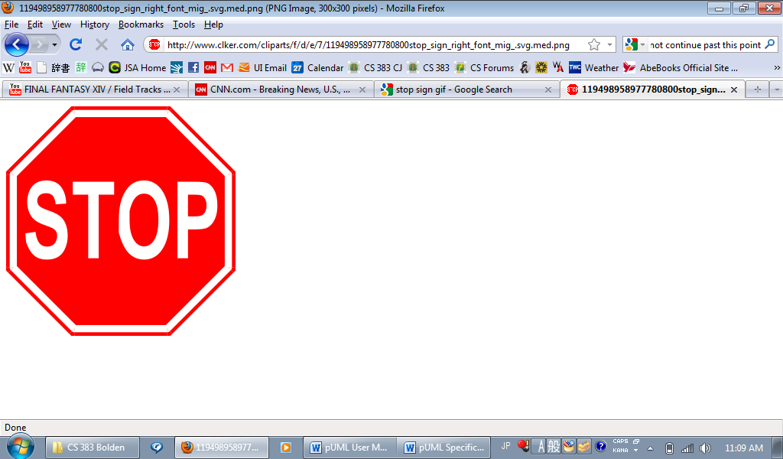

# Introduction to the pUML main window.

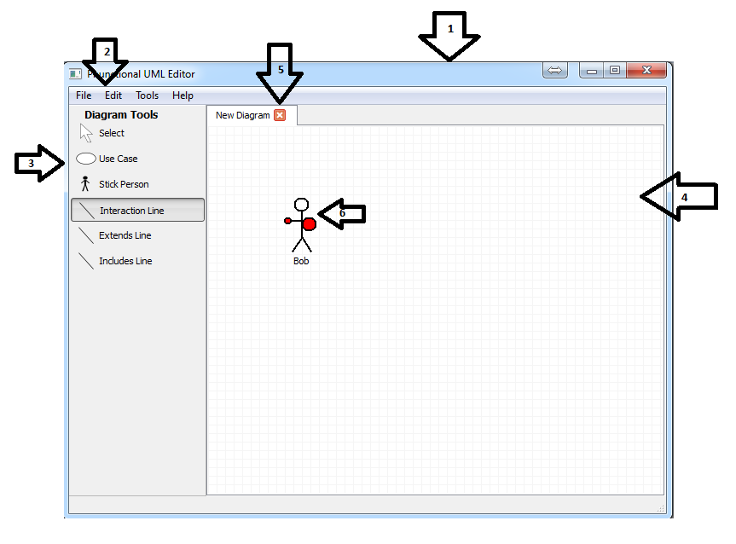

**1. Main Window**

**2. Main Window Toolbar**

**3. Canvas Toolbar**

**4. Canvas**

**5. Tabs for Additional UML Diagrams**

**6. Object on Canvas**

# Create a New Diagram

***When You First Start the Program***

1. Make sure that the “New” option on the left is highlighted.
2. Select the type of diagram that you would like to create and click “OK”.

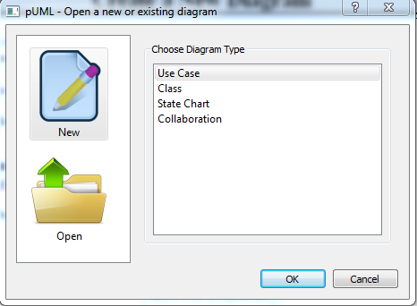

***While You Are Working on Another Diagram***

1. On the pUML main window toolbar, click “File.”
2. Click “New”

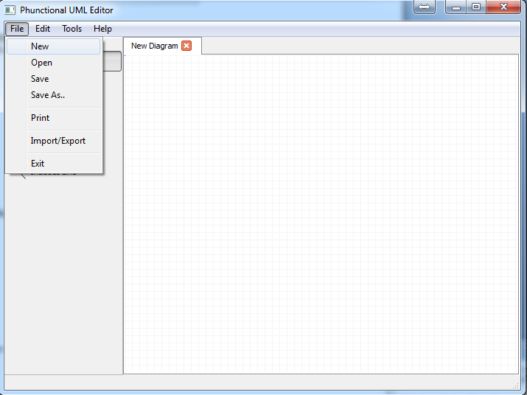

1. Highlight your desired diagram type from the list presented, and click “OK.”

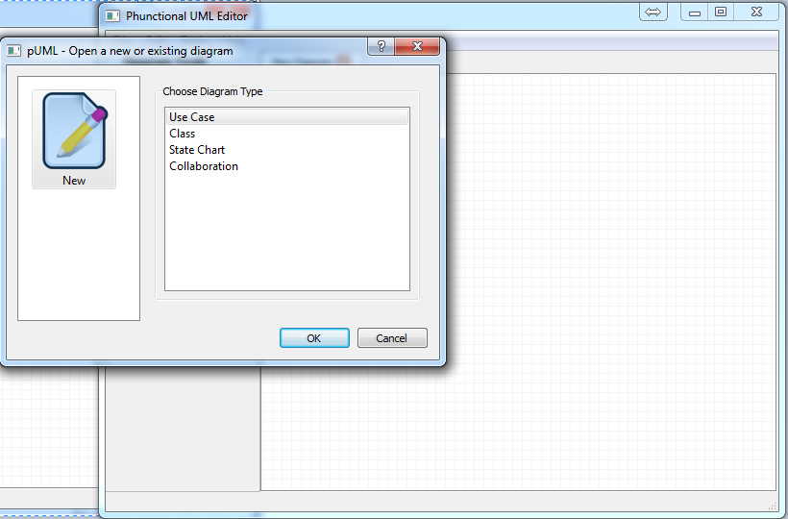

The shapes for your diagram type will appear in the toolbar to the left of the drawing canvas.

**How to place shapes on the canvas:**

1. Click on the desired shape in the toolbar.
2. Click on the canvas to place the selected shape at that location.

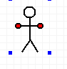 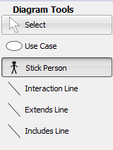

1. Right click on any object and click “properties” in the drop-down menu to add a title or description.

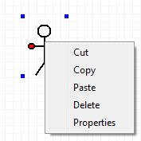 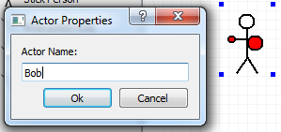

**How to place connectors:**

To place connectors, you must have at least two shapes already on the canvas. To connect the shapes:

1. Click on the desired connector in the toolbar.
2. Click down on the originating object on the canvas and holding the left mouse button down, drag the mouse to the object you’d like to connect to. This will place a connector between the two objects.

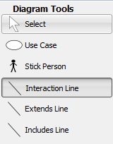 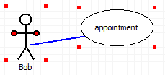 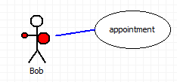

1. Right click on the connector to add a description.

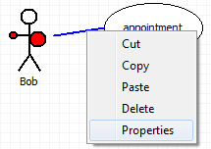

***Note:*** *some connectors have specific descriptions which may not be modified.*

# Editing Your Diagram

**Renaming an object or a connector:**

Right click on the object or connector to change the title or description.

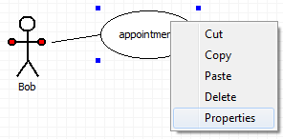 

**Deleting an object:**

There are two ways to delete an object.

1. Right click on the object and select delete.

or, 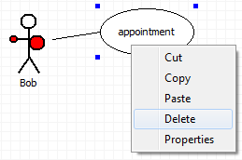

1. Click on the object and press the “Delete” key on your keyboard.  
   The object and any associated description will disappear.

***Warning:*** *When an object is deleted, any associated connectors will be deleted as well. Delete objects with care!*

**Deleting a connector:**

There are two ways to delete an object.

1. Right click on the connector and select delete.

or, 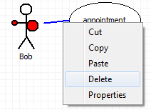

1. Click on the connector and press the “Del” key on your keyboard.  
   The connector and any associated title or description will be deleted.

***Note:*** *Deleting a connector will not delete any associated objects.*

# Help / FAQ

**HELP**

Life’s tough, isn’t it? And on a related note, this program is unsupported at this time.

**FAQ**

Q: How do I delete a pUML UML diagram?

A: Find the diagram on your computer and delete it the same way you would delete any other file on your computer.

Q: I want to embed a picture in my diagram that originates outside pUML.

A: This feature is not supported in pUML.